SANDHILLS FBLA AND FFA HOST SUCCESSFUL FUND RAISER FOR MARCH OF DIMES

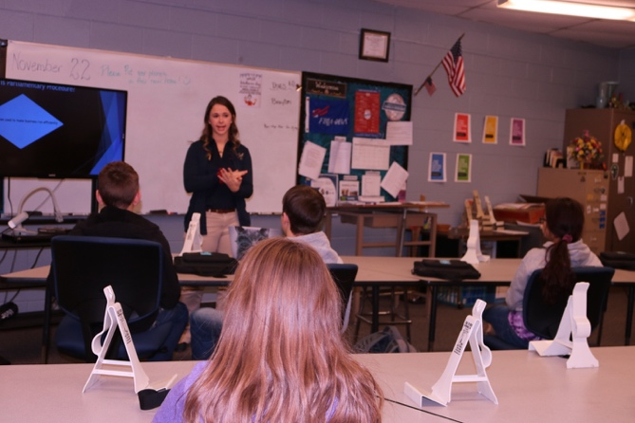
Sandhills Public Schools helped

promote Premature Babies the month of

November 22. A banner was made and

stretched across the hallway promoting

Premature Baby Awareness Month. Facts

Jency Starr explaining to the 7th grade about
basic parliamentary procedure.
were included on the banner. On Friday, November 22, State Parliamentarian, Jency Starr

presented to all the business classes. She explained her role as a state officer and what it takes

to be one. In addition, Jency presented on Parliamentary Procedure and Dressing for Success.

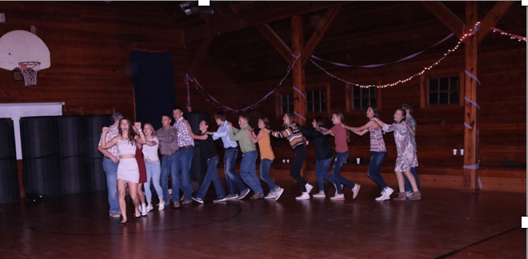
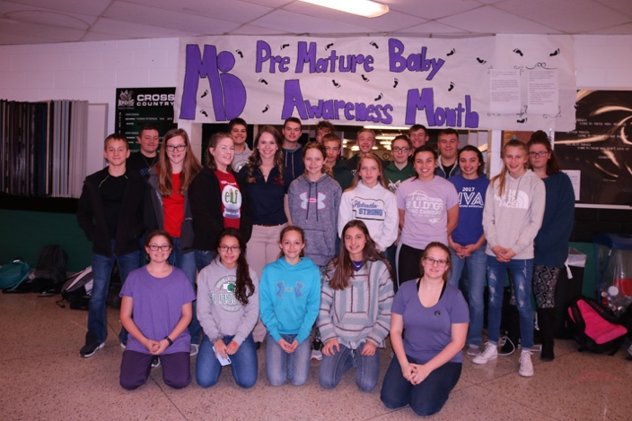
The big event for the March of Dimes was a joint activity of the FBLA and FFA. All officers and committee members helped set up the hall for the dance after school. At 8 o’clock the party started and people started showing up. The dance had an amazing turn out and we collected over $350 for the March of Dimes. Since then we have received several donations which pushed our total over $500! Everyone that has talked about the dance has only said good things about it.

Ending the night with a little bit of “line
dancing!
Celebrating Premature Baby Awareness right!
FBLA photo with Jency Starr.

